Find the lost treasure in Timisoara
Two grandparents of students of our school have managed during the German occupation of Greece in 1942 to reach Timisoara, Romania and hide their money there for greater security. They found three points of area A, B and C, which they used as a guide, as follows:
Point A was the location of Colegiul Tehnic Henri Coandă.
Point B was the location of National College “Constantin Diaconovici Loga”.
They also have written down in a paper the point C. The procedure they followed is depicted in Figure below. Point C is not the real one; it's used to understand the procedure. Point A and B are the real ones.
- Starting from point A directed vertically to AC at AD line segment so that AD = AC (red range).
- Correspondingly, starting from B and directed vertically to the line BC, identified the point E such that BC = BE (Green distance).
- In the middle point X of line segment DE put their money and left.
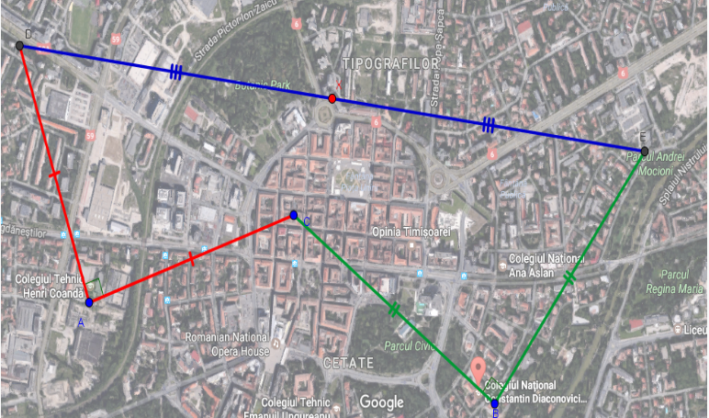
After some years they go to Timisoara to get their money in order to pay a debt to banks. But unfortunately they had missed the paper on which they had noted the point C. Frustrated that cannot follow the steps of their manufacture in order to find the point X come back to Greece and leave behind the buried money forever.

As Geometry students, do you know if we can identify point of money X even without knowing the position of point C?
Try to answer the problem using Dynamic Geometry Software GeoGebra. At first, create and submit a Geogebra file that models the problem.

Question 1
Observe the various positions that the point X of treasure will take if you move points A and B.
Now try to move point C in various positions. What do you notice?

Question 2
Is there a more simple way to find X? Move the C in some "special" places.
A place that can help you is to put the C in the middle of the line segment AB. What do you notice? Did you find where the point X is? What properties it has? How can one move directly from AB to X without using the point C?

Question 3
Can you prove the conjecture that we did? I.e. to prove that point X is the point of the perpendicular bisector of AB for which applies: MX = AM, where M is the middle point of AB.
One might ask: Since we saw in software that it is so, why do we have to prove it? However, although intuition tells us that it will apply for any points A, B, C in the program we have seen what happens in the small area of ​​our screen. If we want to be sure that it is generally the case, we need proof. Only the mathematical proof could explain us why the guess we did is so.

